Unit 2 Day 4 The Distributive Law

Yesterday we explored the concept of adding and subtracting polynomials by removing the brackets. Today, we will learn how to multiply a polynomial by a constant.

Rule: If there is a constant directly outside a polynomial, multiply that constant by EVERY term one at a time and remove the brackets.

Whenever you apply the distributive law, the process you are performing is called EXPANDING.

Examples:

Expand each of the following using the distributive law.

a) 5(x² + 3x – 10) b) 2(–3x + x² – 4)

c) –3(–7x² + 4x) d) –7(–x² – 8x – 9)

We can also have more than one application of the distributive law in a question.

Expand and Simplify

a) 4(x² – 5x) + 6(3x – 2x² – 2) b) 5(3y – 8 – 2y²) – 4(–2y² – 10)

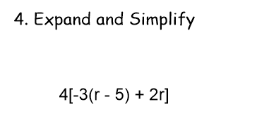

Hmwk : Page 314-315, #’s 1-61 odds, 63, 64, 66

